**Pico CTF Challenge**

**BookMarklet**

**(Pathway)**

**Challenge 4 : BookMarklet**

**Category :** Web Exploitation

**Difficulty :**  Easy

**Description :** Why search for the flag when I can make a bookmarklet to print it for me?

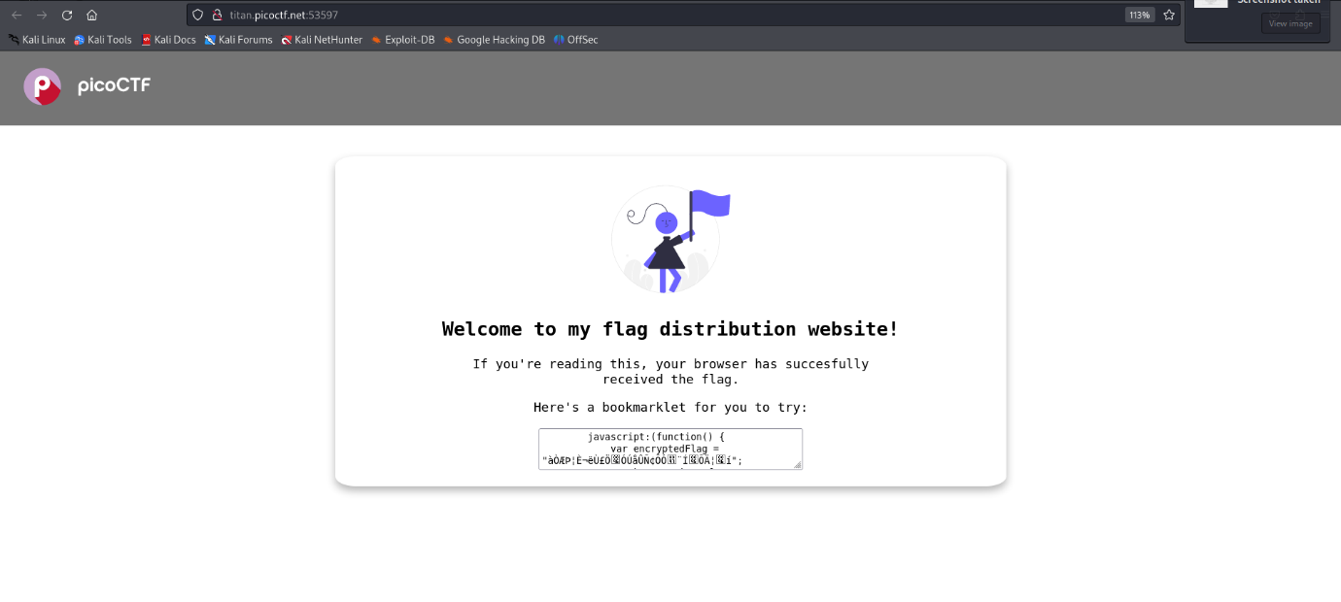Let’s check the web page

In the website a bookmarklet is provided, let’s check inspect of the website.

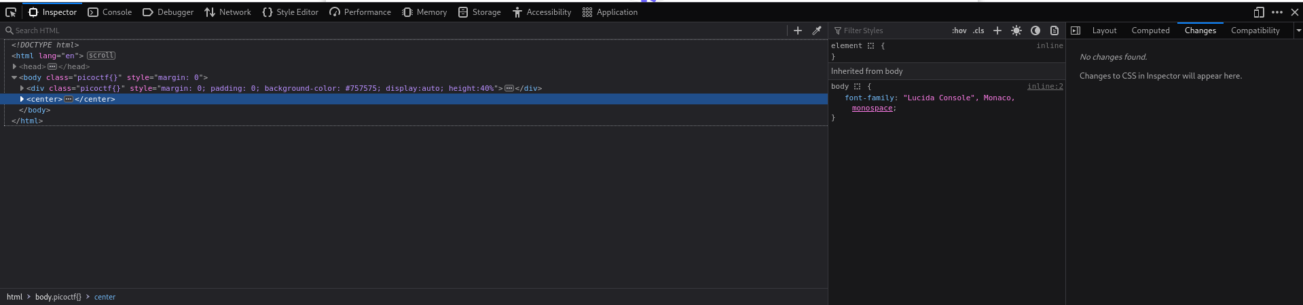

Let’s enter the given bookmarklet in the console.

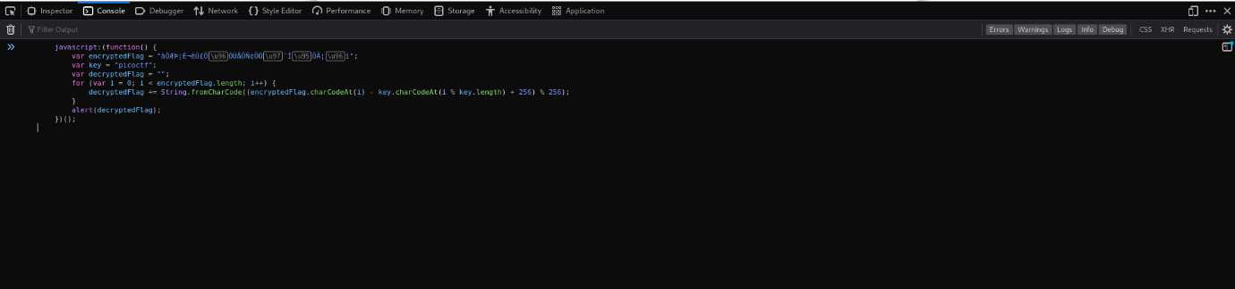

And the Flag is here

